**Name:** Basant Raj Kadel  
**ID:** 80117739

**Lab 5: VLAN Configuration (Access & Trunk)**

**1. Objective**  
To use VLANs on a switch to logically separate devices into two networks (Account Section and Computer Lab) and configure a router for inter-VLAN communication.

**2. Theory**

* **VLAN (Virtual LAN):** Creates separate logical networks on one physical switch. Devices in different VLANs can't communicate without a router.
* **Access Port:** Connects an end device (PC) to a single VLAN.
* **Trunk Port:** Connects switches to routers, carrying traffic for multiple VLANs using VLAN tags.

**3. Configuration**   
**Networks:**

* **VLAN 10 (Account):** 192.168.39.0/27 | Gateway: 192.168.39.1

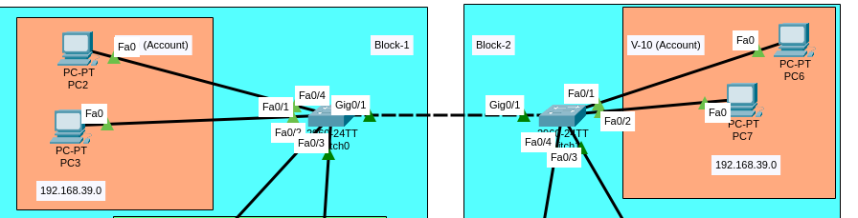

* **VLAN 20 (Lab):** 192.168.39.32/27 | Gateway: 192.168.39.33  
  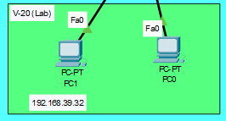 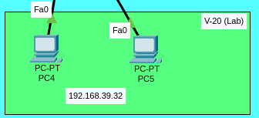

**Switch Commands:   
- On Switch1**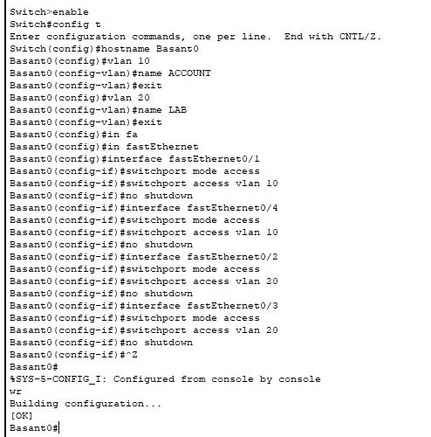

**- On Switch2**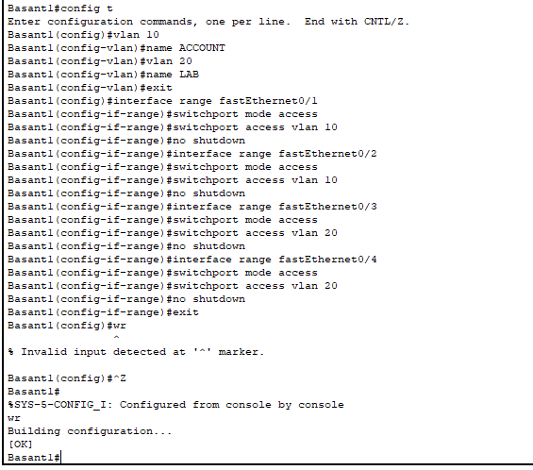

**Configure Trunk Ports**

This is required because the trunk links between the two switches allows VLAN 10 traffic from Switch 1 to reach VLAN 10 PCs on Switch 2, and vice versa.

**On both switches, configure the port connected to the other switch as a trunk:**  
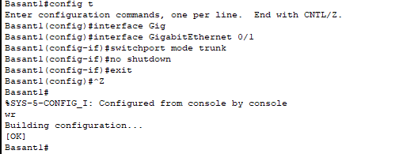

**PC Configuration:**

* **PC2,3,6,7 (VLAN 10):** IP: 192.168.39.2,3,4,5 | Mask: 255.255.255.224
* **PC1,4,5,8 (VLAN 20):** IP: 192.168.39.34,35,36,37 | Mask: 255.255.255.224

**4. Testing**

1. **Test 1 (VLAN Isolation):** ping 192.168.39.34 from PC1 → **Fails.** *Proof that VLANs are working.*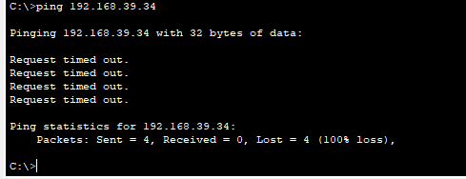
2. **Test 2 (VLAN Routing):** After router config, same ping → **Succeeds.** *Proof router is routing between devices of same VLANs. 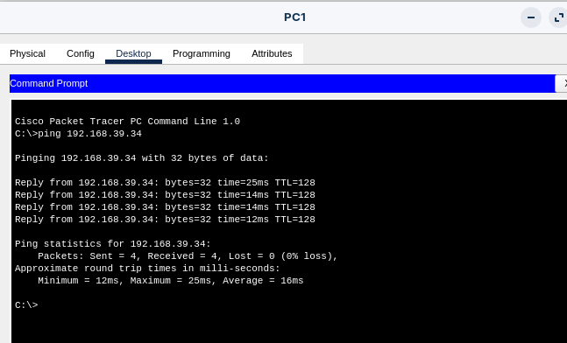*

**5. Conclusion**  
The lab confirmed that VLANs successfully isolate traffic at Layer 2. Communication between devices of same is possible but for communication between VLANs can only be possible after configuring inter-VLAN routing on the router, demonstrating the router's essential role in connecting separate broadcast domains.